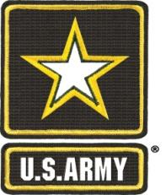
5th Recruiting Brigade
El Paso, TX 79908

Master Sergeant Cole B. Hamilton

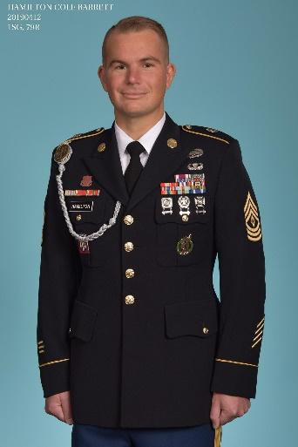
Master Sergeant Cole B Hamilton entered the Army at the Atlanta, GA MEPS as a 12B Combat Engineer on October 5, 2004. MSG Hamilton’s first duty assignment was with the 307th Engineer Battalion, 82nd Airborne Division. Since his time with the 82nd, MSG Hamilton has served as a Squad Leader with the 391st Engineer Battalion in Greenville, SC, as the Assistant Center Commander for the Onalaska Army Recruiting Center, as the Center Leader for the Willingboro Army Recruiting Center, an Overseas Recruiter / Guidance Counselor for the Wiesbaden Army Recruiting Center, First Sergeant for the Northern Iowa Recruiting Company, and the Sr Operations NCO and HHC 1SG for the 5th Recruiting Brigade. MSG Hamilton is currently attending the United States Army Sergeant Majors Academy and will graduate with class 73 in 2023. MSG Hamilton has deployed in support of Operation Enduring Freedom and Operation Iraqi Freedom.

Master Sergeant Hamilton’s Military Education includes the 12B Combat Engineer, the U.S. Army Airborne, the Warrior Leaders, the Basic Noncommissioned Officer, the Army Recruiting, the Center Commander, the Senior Leaders, the Master Resiliency Trainer, the Guidance Counselor / Operations, the Equal Opportunity Leader, Army Basic Instructor, the Small Group Instructor, the USAREC Company Commander / First Sergeant, Master Trainer, Innovative Leader, and Battle Staff NCO courses. MSG Hamilton is a graduate of the U.S. Air Force Senior NCO Academy. MSG Hamilton’s Civilian Education includes a High School Diploma, an Associate of Arts Degree, a Bachelor of Science Degree in Business Management, a Master of Business Administration Degree with a Business Finance concentration, a Master of Arts Degree in Management & Leadership, and a Doctor of Philosophy in Human Resource Management degree.

Master Sergeant Hamilton’s certifications include: Microsoft Teams Administrator Certification, Microsoft Certified Trainer, Microsoft Data Analyst Associate, Microsoft Power Platforms Certification, Microsoft Azure Data Fundamentals Certification, Microsoft 365 Certification, Lean Six Sigma Green Belt, Lean Six Sigma Master Black Belt, Society for Human Resources Certified Professional, Society for Human Resources Senior Certified Professional, Project Management Institute Disciplined Agile Scrum Master, and Project Management Institute Disciplined Agile Senior Scrum Master.

Master Sergeant Hamilton’s Military Awards and Decorations include the Meritorious Service Medal with two bronze oak leaf clusters, the Army Commendation Medal with a silver oak leaf cluster, the Army Achievement Medal with three bronze oak leaf clusters, the Army Good Conduct Medal with three bronze knots, National Defense Service Medal, Armed Forces Reserve Medal with bronze hourglass, Afghanistan Campaign Medal with one Gold Star, Iraq Campaign Medal with two Gold Stars, Global War on Terrorism Medal, Noncommissioned Officer Professional Development Ribbon with a numeral 3, the Army Service Ribbon, the Overseas Service Ribbon with a numeral 2, the NATO ISAF Medal, the Meritorious Unit Citation, the Joint Meritorious Unit Award, the Army Superior Unit Award, the Combat Action Badge, the Basic Parachutist Badge, the Basic Recruiters Badge, the Driver’s Badge with a W device, the Expert Pistol Badge, and the Sharpshooter Rifle Badge.

Master Sergeant Hamilton lives with his wife, Leslie Teal Hamilton, and their sons Cole and Kolin Hamilton. His interests include distance running, gardening, learning, reading, writing, video gaming, and spending time with his family.

Master Sergeant Hamilton’s goals are:
Short Term – Earn the PMI PMP, PMI-ACP, and Project+ certifications.
Long-term – Complete a certificate in data science at the University of Louisville. Earn commandant’s list at the Sergeant Major Academy.

